**DATABASE MONITORING TOOLS**

**DONE BY,**

**V. RUSANDHIYA**

**1. INTRODUCTION**

Database monitoring is the process of **measuring and tracking database performance** according to key metrics influencing it. These metrics are typically monitored in real time, allowing you to identify or predict issues. Effective database monitoring also gives you the opportunity to enhance or optimize your database, to augment overall performance.

Database monitoring tracks the performance of both hardware and software by taking frequent snapshots of performance indicators. This allows us to identify any changes, identify bottlenecks, and pinpoint the exact moment problems started to occur. With this information in hand, we can then rule out potential causes, so we can get to the real root of the issue.

**2. KEY ADVANTAGES OF DATABASE MONITORING**

Successful database monitoring is a fundamental contributor to overall business success. Through the evaluation of user and application activity, monitoring provides us with a complete picture of our database. Implementing a robust database monitoring program can result in crucial advantages for your organization. These include:

* A reduction in the time and resources spent hunting down hidden issues in the database and IT infrastructure
* Improved end-user experiences
* More effective capacity planning
* Ability to troubleshoot performance problems on a proactive basis, before they affect the end user
* Insights into whether and how performance could be improved
* Insights into any security flaws

**3. COMMON APPROACHES TO DATABASE MONITORING**

The two main approaches to database monitoring:

* Proactive and
* Reactive.

3.1. A **proactive** approach aims to pinpoint issues before they become problems, while a reactive approach aims to mitigate the effects of those problems once they have occurred.

3.2**. Reactive** monitoring might be employed for performance troubleshooting, major incident reporting, or a security breach investigation.

The key performance metrics we should consider monitoring to help provide insights into the overall health of a database environment:

* **Queries:**To ensure a high level of overall performance, it’s important to monitor the performance of the queries themselves
* **Capacity issues:** Database issues can be caused by issues with the hardware, like lagging CPU speed or insufficient CPUs, slow disks, misconfigured disks, full disks, and lack of memory.
* **Conflicts among users:** When many users are accessing a database, this can cause conflicting activities and queries. For example, the performance of your database could suffer from page/row locking due to slow queries, transactional locks and deadlocks, or batch activities causing resource contention.
* **Configuration issues:** Disks without proper configuration can cause performance issues. Monitoring will uncover issues like an insufficiently sized buffer cache or a lack of query caching.

**4. DATABASE MONITORING BEST PRACTICES**

* Track availability and consumption of resources
* Measure throughput
* Track and analyze expensive queries
* Monitor changes to the database
* Monitor database logs
* Monitor historical data

1. **THE BEST DATABASE MONITORING TOOLS**

The bigger the server, the more **CPU** and memory are needed to process the data. Using a database monitoring tool is the only reliable way to monitor databases. Similarly, the widespread use of **SQL Servers** has made monitoring SQL Servers a top priority for monitoring **SQL server performance**.

Some of the best database monitoring softwares are:

1.**Paessler PRTG Network Monitor**

2.SolarWinds AppOptics APM

3.Datadog Database Monitoring

4.[**ManageEngine Applications Manager**](https://www.comparitech.com/go/manageengine-applications-manager-learn-more-best-database-monitoring-tools/l/list_dd_d__post__106499/)

5.Site24x7 Server Monitoring

6.Atera

**7.dbWatch Database Control**

**8.Idera SQL Diagnostic Manager**

**9.SQL Power Tools**

**10.Sentry One (SQL Sentry)**

**11.Red-Gate SQL Monitor**

**12.Lepide SQL Server Auditing**

**13.ManageEngine Free SQL Health Monitor**

**14.Spiceworks SQL Server Monitoring**

15. Nagios

16.Opsview

17. Solarwinds database performance analyzer(dpa)

### SOLARWINDS DATABASE PERFORMANCE ANALYZER(DPA)

**[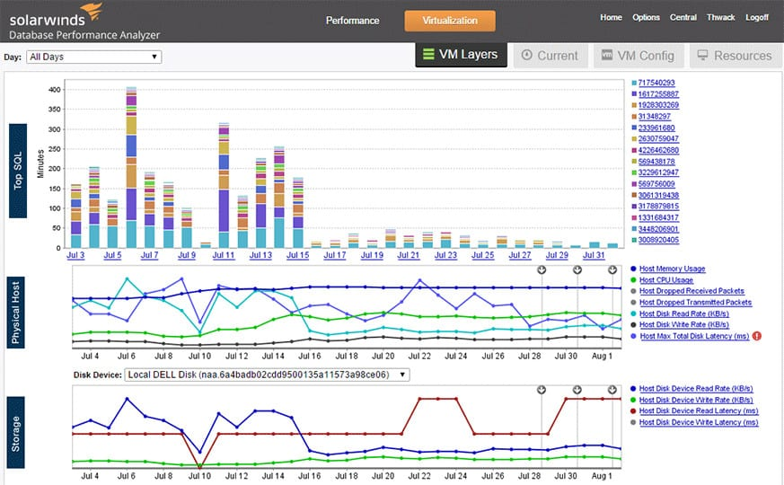](https://www.comparitech.com/go/solarwinds-database-performance-analyzer-sql-free-trial/l/image_dd_d__post__106499/d/106499/d/106499/)Fig 1.1. Visualization of database performance**

* [**SolarWinds Database Performance Analyzer**](https://www.comparitech.com/go/solarwinds-database-performance-analyzer-sql-more-information/l/inline_dd_d__post__106499/d/106499/d/106499/) has become a core tool for network administrators looking to address database problems in real time.
* We can monitor our server performance through the dashboard and **verify the status of a server’s database queries**, **CPU**, **memory**, **disk**, and **sessions**.
* Problematic devices are denoted as yellow for **Warning** and red for **Critical**. We also have the ability to view graphs of your server health to see all emerging trends.

**6.1.1.TIME ANALYSIS:**

* DPA is designed in an intelligent way, combining Response Time Analysis in a multidimensional root cause analysis which also correlates and considers SQL statements, system health, wait-based analytics, and context.
* DPA is popular among admins in need of Oracle monitoring tools, because it’s built to let users optimize production databases through agentless architecture. This means we can use it in development, testing, production, virtualized, and in the cloud (Amazon AWS, EC2, RDS, Azure).

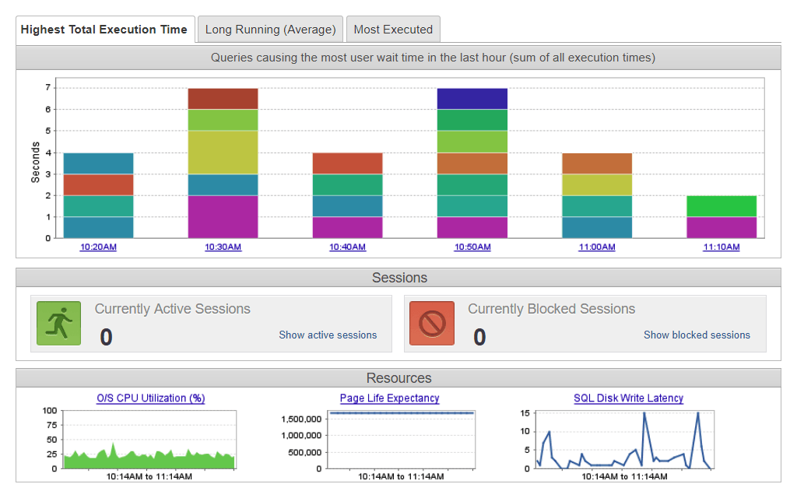**Fig.1.2. Time analysis of execution**

**6.1.2. MONITORING**

We can monitor and verify :

* server query status
* CPU disk usage
* Memory usage and sessions

With the ability to view our server health in the form of graphs to gain a clear overview of any emerging trends. [SolarWinds Orion® Platform](https://www.solarwinds.com/solutions/orion?CMP=ORG-BLG-DNS-X_WW_X_NP_X_X_EN_X_X-ORIO-20200107_11BestDatabaseM_X_X_VidNo_X-X) makes it possible to combine DPA metrics with other useful monitoring tools like [SolarWinds Server & Application Monitor (SAM)](https://www.solarwinds.com/server-application-monitor?CMP=ORG-BLG-DNS-X_WW_X_NP_X_X_EN_X_X-SAM-20200107_11BestDatabaseM_X_X_VidNo_X-X). The Orion Platform is built to provide a centralized dashboard showing database performance metrics from [DPA integrated with SAM](https://www.solarwinds.com/database-performance-analyzer/use-cases/sam-dpa-integration?CMP=ORG-BLG-DNS-X_WW_X_NP_X_X_EN_X_X-DPA-20200107_11BestDatabaseM_X_X_VidNo_X-X) server health tracking for a more comprehensive view of performance across your infrastructure.

**6.1.3 FEATURES:**

Its user-friendly dashboard, real-time insights, integration capacities, and brilliant Response Time Analysis approach make SolarWinds DPA the obvious choice for best database monitoring tool. A [14-day free trial](https://www.solarwinds.com/database-performance-analyzer/registration?CMP=ORG-BLG-DNS-X_WW_X_NP_X_X_EN_X_X-DPA-20200107_11BestDatabaseM_X_X_VidNo_X-X) is available, during which DPA is fully functional.

It’s worth mentioning, a [free version of DPA](https://www.solarwinds.com/free-tools/database-performance-analyzer-free?CMP=ORG-BLG-DNS-X_WW_X_NP_X_X_EN_X_X-DPA-20200107_11BestDatabaseM_X_X_VidNo_X-X) is also available.

It shares some features with the paid version, such as offering response time monitoring with SQL query wait types and wait events; provides a unified view of SQL Server, Oracle, DB2, and SAP ASE instances via a single dashboard; and allows for unlimited users, with no agents and no installation on production servers.

However, the free version of [SolarWinds DPA](https://www.solarwinds.com/database-performance-analyzer/use-cases/sql-database-maintenance-software?CMP=ORG-BLG-DNS-X_WW_X_NP_X_X_EN_X_X-DPA-20200107_11BestDatabaseM_X_X_VidNo_X-X) cannot serve as a replacement for the paid version. As generous an offering as it is, it doesn’t have key features we would gain access to with the paid DPA. The features available in DPA but not the free tool version include:

* Real-time session monitoring and performance analysis for VMware
* Ability to drill down by program, object, database, plan, and more
* Historical trend dashboard, reporting, charts, and alerting
* Customer and technical support, with expert analysis and maintenance
* Ability to go back in time to trace the root cause of past issues
* Support for RDS, Azure, AWS, and MySQL
* Blocking and locking analysis

**6.1.2. MAJOR ADVANTAGE:**

The speciality of this tool is its **root cause analysis** ability. The foundation of this is the opportunity to view how the code works. With this tool, users can monitor a variety of databases. **SQL Server**, **MySQL**, **DB2**, **Aurora**, **virtualized**, and **cloud databases** can all be monitored through this program. The variety of options means that this program functions well in most enterprise environments.

**6.1.3. COST:**

**SolarWinds Database Performance Analyzer**is available from a price of $1,995 (£1,562). It is also available to download on a [**14-day free trial**](https://www.comparitech.com/go/solarwinds-database-performance-analyzer-sql-free-trial/l/cta_dd_d__post__106499/d/106499/d/106499/)**.**

**6.1.4. OS:**

 Windows, Linux or Unix, Azure Marketplace, or AWS launch

### 6.2. PAESSLER PRTG NETWORK MONITOR

**[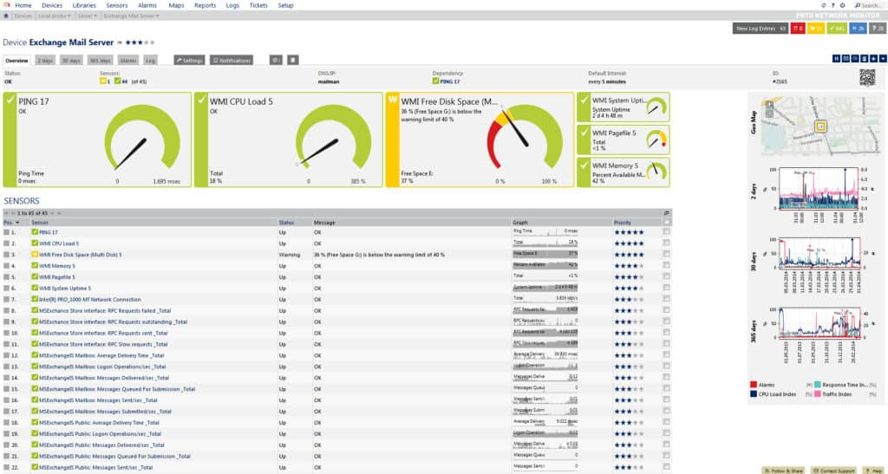](https://www.comparitech.com/go/paessler-prtg-database-monitor-free-trial-3/)**

**Fig 2. Database visualization**

* **Paessler PRTG Network Monitor,** a network monitoring tool that boasts a sizeable SQL monitoring ability. This program can monitor common databases such as **Microsoft SQL**, **MySQL**, **Oracle SQL**, and **PostgreSQL**.
* For a network monitoring tool, **PRTG Network Monitor**is also straightforward to set up. **PRTG Network Monitor** comes equipped with sensors that have been configured out of the box. These pre-configured settings cover most large database providers like **Microsoft SQL**, **MySQL**, and **Oracle SQL**.
* Overall, **PRTG Network Monitor** is a product that combines general network monitoring ability while simultaneously providing a compelling experience for database monitoring. There are several pricing options available for **PRTG Network Monitor**. This starts with a freeware version of **PRTG Network Monitor,** which allows the **monitoring of up to 100 sensors** for free.

**6.2.1. ADVANTAGE:**

* This has the advantage of eliminating the need for us to configure our configurations from nothing. This allows us to clearly see the performance of your database under pressure.
* **PRTG Network Monitor**can be used to monitor the execution time for an SQL query. The tool will measure the time from the moment the connection was established right through the transfer to the end of the connection.

**6.2.2. COST:**

An unlimited version of PRTG is available at no cost**.** The first paid version of **PRTG Network Monitor** costs $1600 (£1253) for 500 sensors. The next three products for larger organizations cost $2850 (£2,232) for 1000 sensors, $5950 (£4,662) for 2500 sensors and $10500 (£8,227) for 5000 sensors. Organizations that need to monitor even more can download the XL1 Unlimited version, which supports unlimited sensors for $14500 (£11,361). There is also a [**30-day free trial**](https://www.comparitech.com/go/paessler-prtg-database-monitor-free-trial-5/) available for downloaded.

### 6.3. SOLARWINDS APPOPTICS APM

**[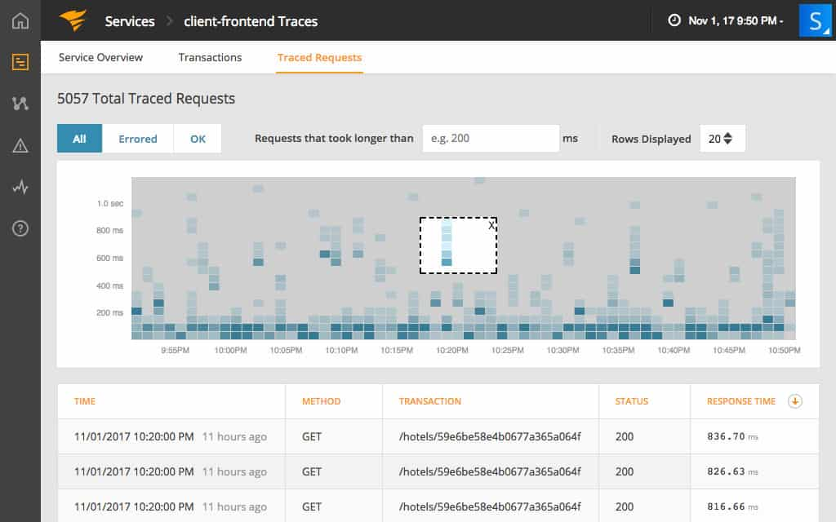](https://www.comparitech.com/go/appoptics-application-performance-monitoring-more-info/l/image_dd_d__post__106499/)**  
**Fig 3. Monitoring visualization**

[**AppOptics APM**](https://www.comparitech.com/go/appoptics-application-performance-monitoring-more-info/l/inline_dd_d__post__106499/) is **a cloud-based service** that monitors the performance of applications and the infrastructure that supports them. A lower edition, called **AppOptics Infrastructure** just focuses on the performance of equipment and doesn’t include the application performance monitoring features of the APM package.

APM has specialist screens for different applications, including databases. The service can interact with a long list of database management systems including **Microsoft SQL Server, MySQL, Oracle, Postgres, and Apache DBMSs**.

**6.3.1. FEATURES**

The tool can **examine queries** as they run on our database, spotting those that seem to be taking too long or behaving inefficiently. When the monitor spots a poorly performing query, it makes a trace file of all of the database transactions that it performs, which enables further analysis.

Other features in the tool examine the code of programs that include SQL database queries and also any batch files and SQL scripts that we might have on our system. This feature**identifies lines of code and clauses in SQL that should be altered** to improve performance.

It is also able to supervise the performance of applications running on rented virtual servers run by **AWS** or **Azure**servers. If we have a hybrid on-premises/cloud system, then that can be monitored by the service as well.

**6.3.2. COST:**

As a cloud service, AppOptics is **charged for by subscription**. The service has a flat fee per year and it doesn’t matter how many staff access the service. As well as the APM and infrastructure-only plans, SolarWinds offers a cheaper Metrics Pack. However, to get database monitoring features, we have to go for the APM edition

[**6.4. DATADOG DATABASE MONITORING**](https://www.comparitech.com/go/datadog-databases-learn-more-best-database-monitoring-tools/l/header_dd_d__post__106499/)

**[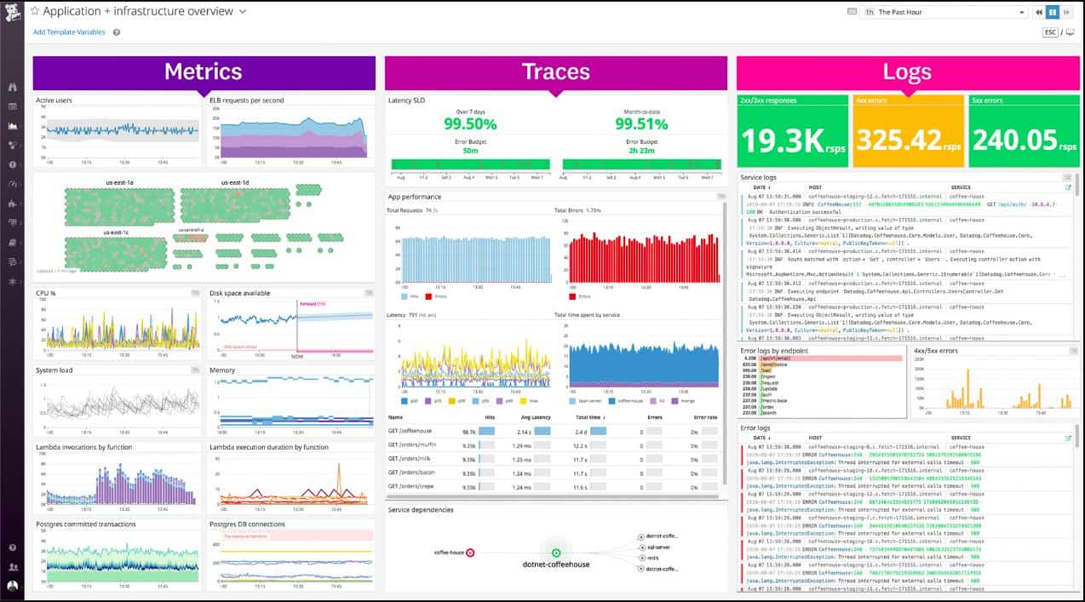](https://www.comparitech.com/go/datadog-databases-learn-more-best-database-monitoring-tools/l/image_dd_d__post__106499/)**

**Fig 4. Datadog database monitoring**

* [**Datadog Database Monitoring**](https://www.comparitech.com/go/datadog-databases-learn-more-best-database-monitoring-tools/l/inline_dd_d__post__106499/) is a SaaS application monitor that includes extensive database monitoring capabilities.
* The Datadog system includes **AI machine learning techniques** that establish normal performance profiles for applications and infrastructure over time.
* This enables the system to automatically set alert thresholds and cut down the number of notifications that administrators receive.

It includes over 400 turn-key integrations including Cassandra, Redis, PostgreSQL MongoDB, SQL Server, MySQL, and more.

Although alert thresholds are set automatically, they can be adjusted and it is also possible to **create custom conditions** that would trigger alerts. These can be created by combining existing performance checks by using a straightforward SQL query tool.

**6.4.1. PERFORMANCE MONITORS:**

* The performance monitor has a lot of **database performance visualizations** and, when combined with infrastructure or website monitoring modules, can show exactly where any performance issue in our IT system originates.
* The APM will cover server performance metrics as well as application delivery checks.

**6.4.2. EASE OF ANALYSIS:**

* The screens of Datadog enable **fast problem recognition** through charts, maps, and color coding and they include a number of troubleshooting investigative tools.
* The user can reorganize graphs to create a simultaneous performance stack to make analysis easier.
* As a cloud-based service, Datadog can monitor databases wherever they are. So, we can **centralize the monitoring of services** located on several different sites and it is also possible to watch cloud databases with this system.

**6.4.3. INGEST:**

There is a certain amount of service performance logging with the Datadog APN package. However, to get standard database logs and other system logs analyzed properly, we would probably need to get the company’s log management module as well – it is called **Ingest**.

**6.4.4. DATADOG VISUALIZATION:**

Datadog visualizations and performance analysis reports are great for communicating the current state of your databases and their future needs to stakeholders. Information can be distributed through an integration with Slack, or through other team collaboration tools.

**6.4.5. COST:**

Datadog Database Monitoring and all other Datadog modules can be experienced on **14-day free trials**.

**6.5. MANAGEENGINE APPLICATIONS MANAGER**

**[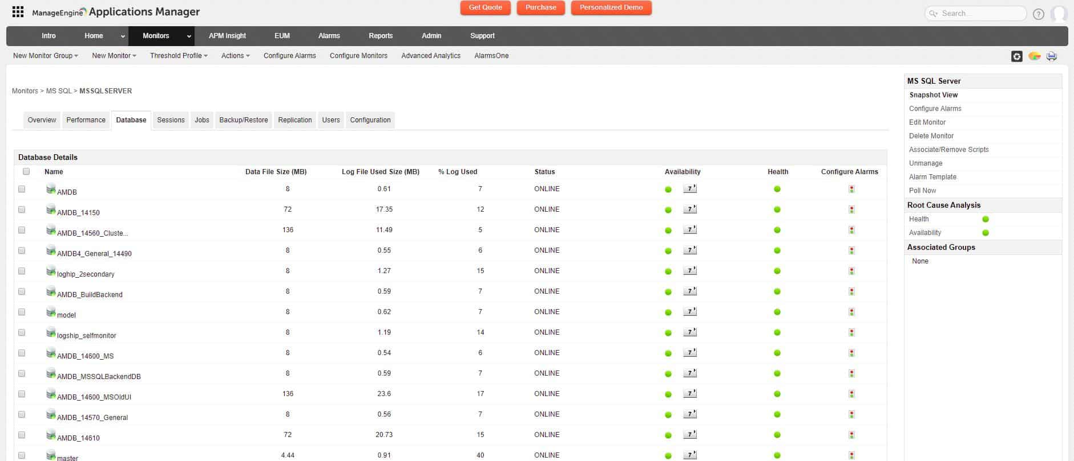](https://www.comparitech.com/go/manageengine-applications-manager-learn-more-best-database-monitoring-tools/l/image_dd_d__post__106499/)**

**Fig 5.1 ManageEngine applications engine database visualization**

**ManageEngine** offers **database monitoring** as part of its [**Applications Manager**](https://www.comparitech.com/go/manageengine-applications-manager-learn-more-best-database-monitoring-tools/l/inline_dd_d__post__106499/) system. This software package also covers **server performance**, so we can drill down and examine the physical support for our databases as well as checking on the operating metrics of our databases.

**6.5.1. MONITORING SERVICES:**

The monitoring services of the Applications Manager have specialized procedures to monitor **relational databases**, including Oracle, MS SQL, MySQL, IBM Informix, IBM DB2, Sybase, and PostgreSQL. **NoSQL databases** are also included in the monitoring capabilities of Applications Manager. This includes Oracle NoSQL, MongoDB, Cassandra, Couchbase, and Apache HBase. **Big data stores**, such as Hadoop and **in-memory databases**, including Oracle Coherence, SAP HANA, and Redis and also covered.

The monitor will watch database-specific metrics and also examine the dependencies of other applications that rely on databases, such as **web servers**, and how the interactions between the server and the database management systems perform.

The main database performance monitoring screen in the Applications Manager is tabbed. This removes the need to constantly leave the environment and go back to the main Applications Manager menu in order to observe other categories of database statuses.

**[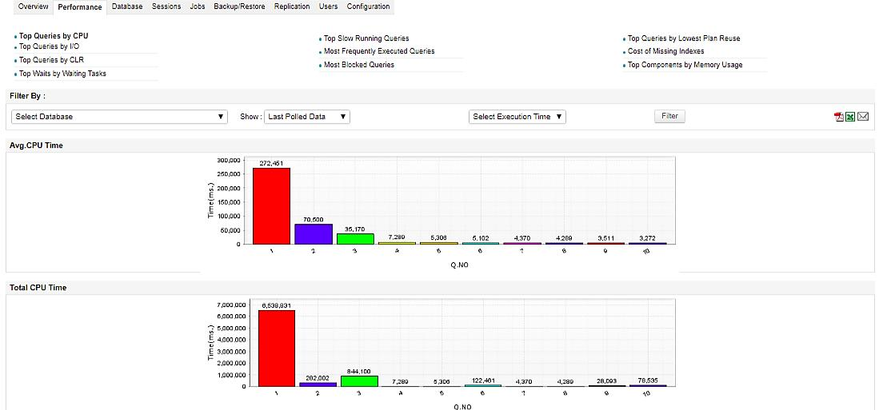](https://www.comparitech.com/go/manageengine-applications-manager-learn-more-best-database-monitoring-tools/l/image_dd_d__post__106499/)**

**Fig 5.2.Time monitoring**

**6.5.2. TIME ANALYSIS:**

The monitoring tool will show **live response times** as an overall statistic for all databases, allowing a **drill down** on metrics per DBMS and then per instance. Monitoring categories include database-wide factors, such as **memory and disk usage**, **I/O speeds**, and **buffer statuses**. It also has transaction information on all SQL performance, which can also be analyzed. These different tabs offer a range of monitoring services that cover hour-by-hour service requirements and analytical tools for database optimization and query refinements.

**6.5.3. AVAILABILITY:**

ManageEngine Applications Manager installs on **Windows Server** and **Linux**. All of the server and application monitoring capabilities of the tool are available to all buyers – there aren’t any partial versions or incremental purchase plans. The tool is available for a **30-day free trial**.

### 6.6. SITE24X7 SERVER MONITORING

[](https://cdn.comparitech.com/wp-content/uploads/2019/03/Site24x7-Server-Monitoring.gif)

**Fig 6. Site24x7 server monitoring**

**Site24x7 Server Monitoring** offers **network, server, and application monitoring**. This combination is ideal for keeping the performance of your databases in a good state. The system is a cloud-based service, so you don’t have to install any database monitoring software to use it. This configuration makes it a great tool for monitoring remote sites and it also **works well for MSPs**.

**6.6.1. PERFORMANCE OPTIMIZER**

The application monitors in this bundle include **a database performance optimizer**. It will **automatically discover all of our databases** and install agents to keep tabs on them. These agents report back to the central Site24x7 system, where we can access results through a browser.

Performance metrics are shown live on the screen, and we can set alert parameters that enable us to head off overloading. As the tool can monitor any number of instances, it is a good assistant for coordinating between distributed databases and between production and development environments. The **reporting utility** in the tool will help you analyze the performance of our databases over time.

**6.6.2. AVAILABILITY**

Site24x7 is charged for on **a subscription model** and the different plans and add-on options make it possible to create a custom package that is tailored to your business’s needs. There is even **a free version**, which limits monitoring to just five servers. You can try out the system on a 30-day free trial. If you decide not to buy at the end of that period, your account gets switched over to the free edition.

### 6.7. ATERA

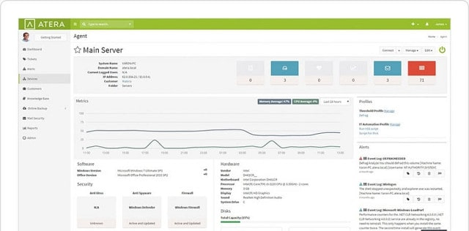

**Fig 7. Atera visualization**

**Atera** is **a cloud-based service** that supports managed service providers (MSPs). The platform includes both remote monitoring and management (RMM) and professional services automation (PSA). So, it includes all of the software that an MSP needs to conduct its business.

**6.7.1. FEATURES:**

* The monitoring features of Atera include the tracking of **live statuses** and also **database log file monitoring**. Any database problems that arise will be caught by one of those two methods and converted into alerts in the system dashboard.
* One of the remote management services included with the Atera RMM is the ability to **manage database backup and recovery procedures** through the tool. This feature doesn’t implement the backup and restore process directly – it is better to use the native procedures built into the DBMS.
* However, the Atera interface can interact with the DBMS of multiple vendors, which means that a systems administrator working as part of an MSP team can perform all backup and recovery tasks through one dashboard.
* The Atera system can interact with the database management systems for **MS SQL Database Server**, **MySQL**, and **Oracle**.
* As an online service, Atera is billed on a subscription basis. Prices are levied per technician per month, which makes the service ideal for a small MSP or independent technician. The prices are lower for those who opt to pay annually. However, the service has to be **paid for in advance** whichever billing period you choose.

**6.7.2. ATERA EDITIONS:**

Atera is available in three editions: **Pro**, **Growth**, and **Power**. All editions include the regular database status monitoring feature and all include database backup and recovery procedures. However, the top plan, Power, also includes the ability to store database snapshots.

**6.7.3. AVAILABILITY:**

Atera is available for a 30-day free trial.

### 6.[8. dbWATCH DATABASE CONTROL](https://www.dbwatch.com/)

**[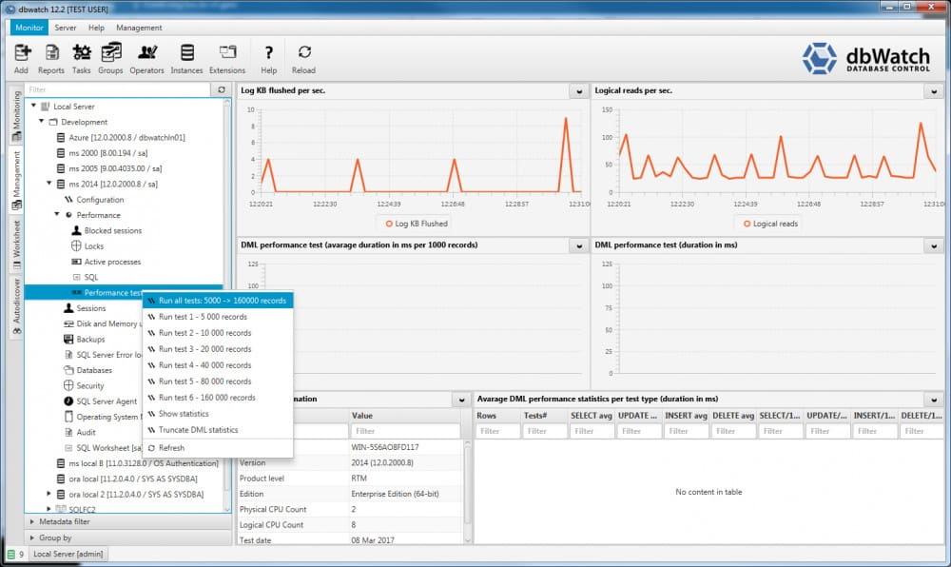](https://cdn.comparitech.com/wp-content/uploads/2018/10/dbwatch-performance-management-run-tests.jpg)**

**Fig 8. dbWatch database monitoring**

Norway-based **dbWatch Database Control** is a specialized database monitoring tool – it doesn’t form part of a generalized infrastructure monitor. So, this tool is a good choice if we already have all of our server and application monitoring tools in place but lack insight into the performance of our databases.

**6.8.1. PRICING:**

The tool is implemented as an on-premises database monitoring software. We pay for a license based on the number of databases that you want to monitor. The pricing structure begins with a minimum database coverage of ten.

**6.8.2. MONITORING**

The tool can monitor a range of databases in **real-time** and it also gathers **historical data** for analysis and reporting. Views and reports can be accessed on each individual database, or as an overall view of the performance of all of our databases.

It doesn’t matter if we have RDMSs from several providers on our site because the tool can monitor different types of databases all at once. It can monitor **SQL Server**, **Oracle**, **Sybase**, **MariaDB**, **MySQL**, and **Postgres** databases. It doesn’t matter where those databases are because dbWatch can oversee remote and cloud-based databases as easily as it can monitor on-premises instances. It is also able to oversee SQL Server and Oracle clusters, and it can interface with Azure SQL on the cloud.

The dbWatch package is available in three service plans. These are **dbWatch Essentials**, **dbWatch Professional**, and **dbWatch Enterprise**. The Essentials package gets you all of the database monitoring tools. The Professional plan adds on automation for maintenance tasks and it also includes license management for SQL Server and Oracle databases. The Enterprise package includes database autodiscovery and cluster management.

The dbWatch software installs on hosts running the windows, Mac OS, and Linux operating systems.

### 6.9. IDERA SQL DIAGNOSTIC MANAGER

[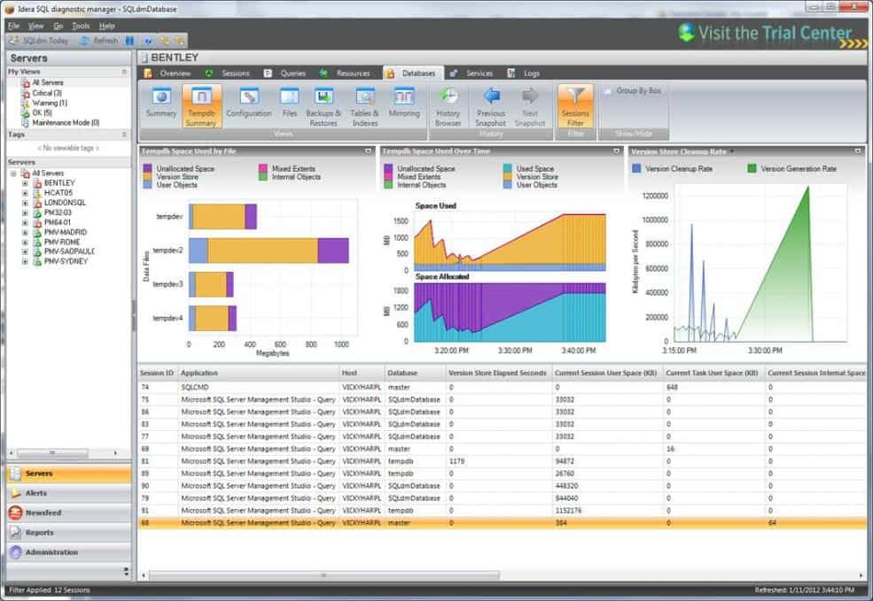](https://www.idera.com/productssolutions/sqlserver/sqldiagnosticmanager/productdetails)

**Fig.9.Idera diagnostic manager**

* When it comes to diverse database monitoring solutions, **Idera SQL Diagnostic Manager** is hard to beat. This SQL monitoring tool can monitor databases in both physical and virtual environments.
* This program has been specifically designed to help the user view key performance metrics. Metrics we’ll encounter on **Idera SQL Diagnostic Manager** include **CPU**,**Hard Disk Usage**, **Space**, **Network Usage**, and **Memory**. This data gives you the basics we need to assess how well a database is performing.

We can also view what is happening through the lens of **transaction analysis**. This allows us to view application problems in isolation. For example, **SQL Workload Analysis** combines granular state monitoring and query plan tuning together with recommendations. This allows us to make targeted changes to address poor performance issues.

**6.9.1 ALERTS**

Alerts notify us when certain data occurs. We can set our alert thresholds so that we are notified when specific events happen. There is also a predictive alert facility that shows a percentage detailing the likelihood that a particular event will happen.

**6.9.2. AVAILABILITY:**

**Idera SQL Diagnostic Manager** is one of the most accessible products on the market. It mixes a compelling user interface available online and as a mobile app to help you monitor effectively. We can purchase the Pro version of **Idera SQL Diagnostic Manager**for $999 (£782). We can also download this tool as a [**14-day free trial**](https://www.idera.com/productssolutions/sqlserver/sqldiagnosticmanager/productdetails)**.**

### 6.10. SQL POWER TOOLS

[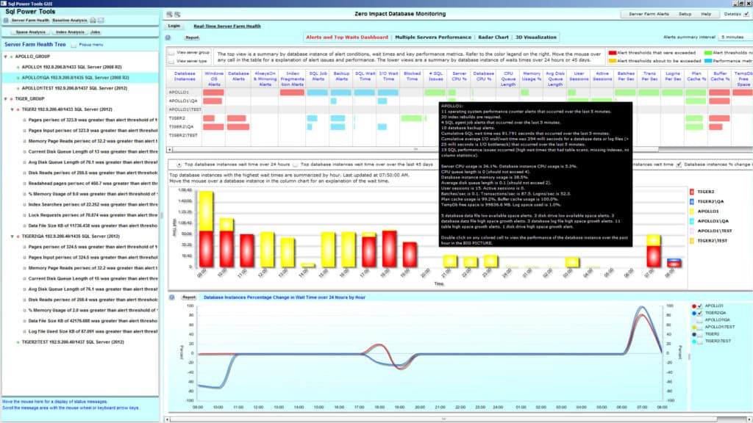](http://www.sqlpower.com/eval/)

**Fig 10. SQL power tool monitoring visualization**

* Back in 2000, **SQL Power Tools**began to develop a name for itself as a staple tool for all things SQL monitoring.
* This product remains popular as one of the most lightweight products on account of its deployment.
* **SQL Power Tools** logs database metrics including **response time**, **destination IP**, **source IP application**, **login id**, **bytes sent**, and **packets sent** etc.

**6,10.1. FEATURES**

**SQL Power Tools**also delivers a high-quality experience in terms of cybersecurity. **Advanced Behavioral Analysis** and user **Entity Behavioral Analytics** help the user to identify threats and respond accordingly. If a hacker accesses your system, the breach will be identified promptly and the activity stopped ASAP.

The general monitoring experience offered by **SQL Power Tools**is extensive. We can look at everything from SQL wait times to stall times, blocking, and deadlocks. We can even view these in 3D graphs which makes it much easier to understand what’s going on.

**6.10.2. AVAILABILITY**

**SQL Power Tools** is a tool that still provides a contemporary monitoring experience despite its age. However, you will need to contact the sales team to view a quote for purchasing this product. That being said, we can also download a free trial.

### 6.11. SENTRY ONE (SQL SENTRY)

[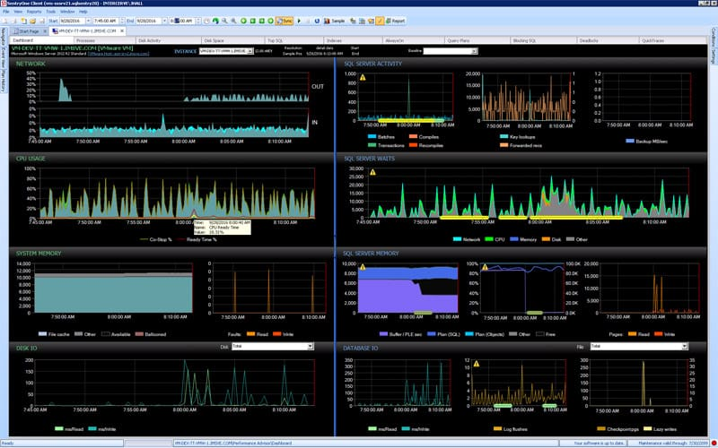](https://my.sentryone.com/trial?)

**Fig.11. Sentry visualization**

* **Sentry One** is a product that takes an old-school approach to database monitoring
* With **Sentry One**you can view real-time data on your databases through the performance monitoring dashboard.
* All the data displayed allows us to see how available your SQL servers are critically.

**6.11.1. ALERTS**

Like other top-end database monitoring products, **Sentry One** also has its own alerts system. In fact, there are **over 100 alerting conditions available out of the box**. These alerts notify you both when servers go down and when databases are taking too long to process data. We can even**customize our alert message text**to help our staff to respond to problems more effectively.

**6.11.2.FEATURES**

This program also offers automated**index defragmentation and visual deadlock analysis**. It helps you to know exactly when you need to perform defragmentation. This is informed by a combination of live and historical data so that you can get a balanced perspective.

In many ways, **Sentry One** is a program that deserves more attention as it offers a database monitoring experience that is much more sophisticated than its initial appearance.

**6.11.3. AVILABILITY**

**Sentry One is available as a License or a Subscription**. The License version can be purchased for $2,495 (£1,955) and provides technical support and updates. The Subscription version can be purchased for $125 (£97.95) per month. There is also a [**15-day free trial**](https://my.sentryone.com/trial?)available for download.

### 6.12. RED-GATE SQL MONITOR

[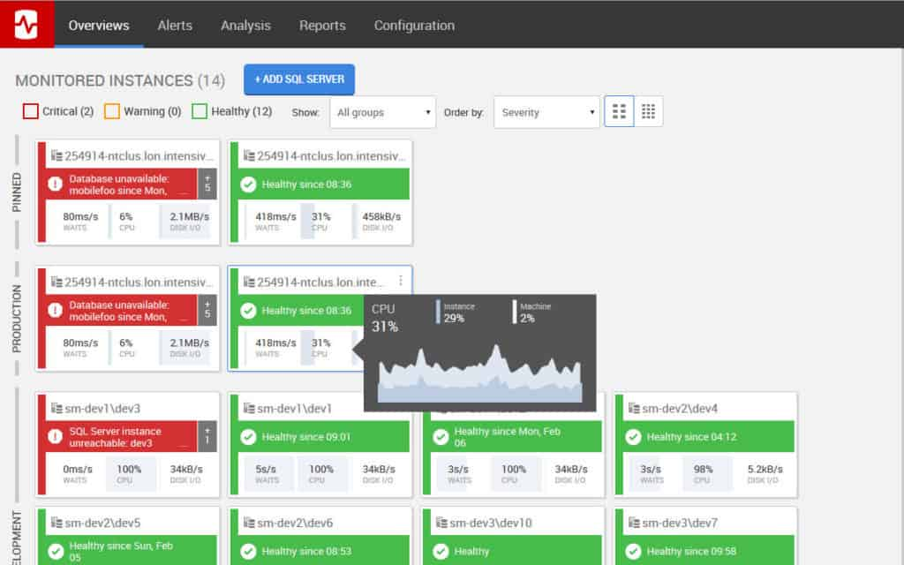](https://www.red-gate.com/dynamic/products/dba/sql-monitor/download)

**Fig.12.1. Database visualization using red gate sql monitor**

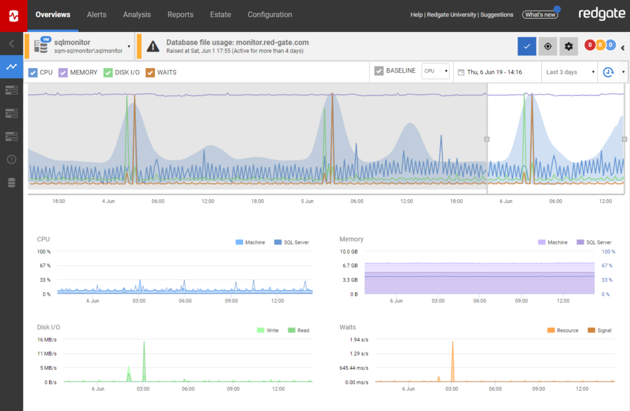

**Fig.12.2. Database visualization of cpu, disk space using red gate sql monitor**

* **Red-Gate SQL Monitor**. **Red-Gate SQL Monitor**is a program that’s SQL monitoring abilities are as striking as its visual design.
* With this tool, we can monitor all of our SQL databases through one dashboard on the web-based GUI. Our servers will be color-coded and we can identify what their status is in seconds.
* There is a traffic light system with a green light for **Healthy**, amber for **Warning**, and red for **Critical**.

One of the great things about **Red-Gate SQL Monitor** is that the **web-GUI updates every 15 seconds**. This means that we can track live activity without falling behind. This is particularly advantageous for dealing with problems as they emerge in more extensive networks.

**6.12.1.ALERTS**

There are also a variety of alerts that you can take advantage of. We can **use alerts for high CPU**, **memory**, **low disk space**, **SQL errors**, and **performance issues**. In total, 40 customizable alerts come with **Red-Gate SQL Monitor**out of the box. This provides you with everything you need to stay on top of what is happening on your network.

**6.12.2. AVAILABILITY**

There are a variety of pricing options available for **Red-Gate SQL Monitor**based on how many servers you want to monitor. If we want to monitor one to four servers then we can do so for a price of $1,495 (£1,171) per server. If this isn’t enough then we can purchase for five to nine servers for $1,271 (£995). However, we’ll need to contact the company directly if we want to see the price for 10+ servers. There is also a [**14-day free trial available**](https://www.red-gate.com/dynamic/products/dba/sql-monitor/download)**.**

### 6.13. LEPIDE SQL SERVER AUDITING

[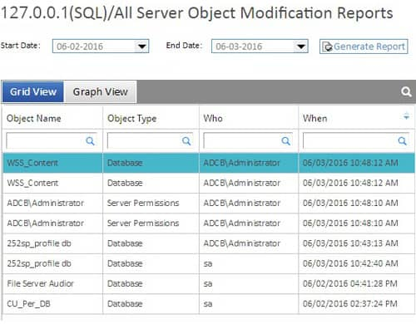](https://www.lepide.com/lepideauditor/sql-server-auditing.html)

**Fig.13.Lepide SQL server monitoring**

**Lepide SQL Server Auditing** is a product that has been used by many big names over the years. Brands from Cisco and Intel to Coca-Cola have called on **LepideAuditor** to protect their data over the years. This is no surprise given that this product offers one of the most complete platforms for live and historic SQL monitoring.

**6.13.1. FEATURES**

The user experience on **Lepide SQL Server** is driven through the dashboard where we can view all Our SQL Servers. The dashboard has been designed so that we can see changes to configurations and permissions instantly. It also allows us to view our databases in a hierarchical format. For example, you **can view your top 10 active databases and failed logins**.

**Lepide SQL Server Auditing**is used widely for many reasons, but many administrators use it because of its cybersecurity credentials. This program allows us to **monitor any changes made to user permissions**. If  a suspicious change has been made we will be sent an alert. These **alerts operate in real-time and can even run custom scripts** to allow the user to configure the automated threat response.

As far as SQL Monitoring goes, **Lepide SQL Server Auditing** is a program that is highly recommended for administrators looking to stay protected against external threats. To view pricing options for **Lepide SQL Server Auditing** we need to contact the sales team.

### 6.14. MANAGEENGINE FREE SQL HEALTH MONITOR

[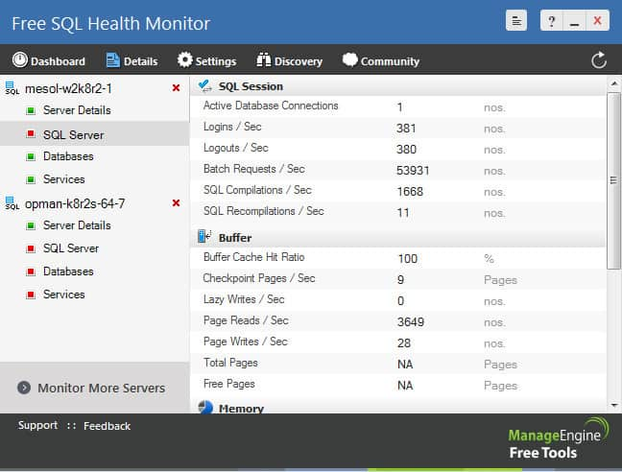](https://cdn.comparitech.com/wp-content/uploads/2018/08/ManagEngine-Free-SQL-Health-Monitor.jpg)

**Fig.14.1. ManageEngine Free SQL Health**

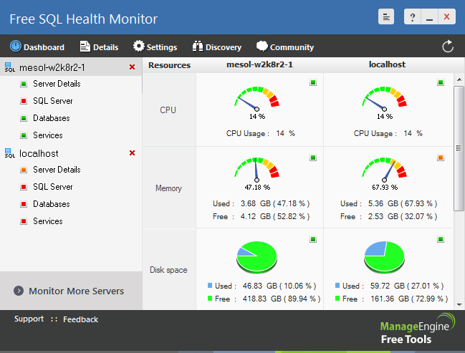

**Fig.14.2. ManageEngine Free SQL Health monitoring**

**ManageEngine Free SQL Health Monitor** is a tool that provides a premium yet affordable SQL Monitoring experience. With **ManageEngine Free SQL Health Monitor**we can **monitor all versions of MS SQL including MS 2012**and **MS SQL 2014**

The user interface delivers the high-level production value that one would expect from a **ManageEngine**product. There is a clear performance monitoring dashboard where we can **monitor the key metrics of our MS SQL servers** with information such as **CPU**, **memory**, and **disk space utilization**being displayed. This provides you with a centralized location where you can take a magnifying glass to your MS SQL servers.

On the other hand, the SQL server monitoring abilities of this product allow you to view data on the **log files used**, **active transaction data**, **transactions per second**, and **log cache hit radio**. This is a healthy mix that allows you to look below the surface to solve problems. This is added by being able to set warning thresholds based on metrics like **disk space**, **memory**, and **CPU**.

**6.14.1.SETUP**

In terms of setup, **ManageEngine Free SQL Health Monitor** is straightforward to set up. You can even **autodiscover SQL servers** throughout your network. This is massive because it means you don’t have to waste time adding servers manually. This means less time configuring and more time monitoring.

**6.1.4.2. AVAILABILITY**

You can download [**ManageEngine Free SQL Health Monitor**](https://www.manageengine.com/sql-performance-monitor/sql-server-monitoring-index.html) for free.

### 6.15. SPICEWORKS SQL SERVER MONITORING

[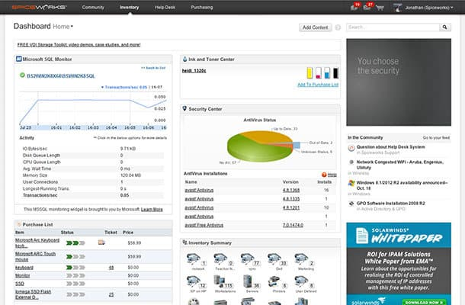](https://www.spiceworks.com/free-sql-server-monitoring-tool/)

**Fig 15.Spiceworks monitoring**

* SpiceWorks is another well-known name in the network monitoring space, and **SpiceWorks SQL Server Monitoring**is a platform that showcases this company’s prowess in creating infrastructure monitoring products.
* With **Spiceworks SQL Server Monitoring**we can check the health of your servers minute by minute on SQL databases from **SQL Server 2005 and up**.

**6.15.1. FEATURES**

Customizable charts and graphs are an area where SpiceWorks excels. We can **create charts**that change the perspective you take of your servers. For example, you can**select or deselect** metrics such as **IO** **Bytes/sec**, **Disk Queue** **Length**, **CPU Queue Length**, and **Processes Blocked**. The result is the ability to analyze your server performance in different ways.

This is also true of the **customizable dashboard**where we can choose precisely how our monitoring environment is structured. We can create your own widgets and dedicate them to server data as needed.

**6.15.2. AVAILABILITY:**

**SpiceWorks SQL Server Monitoring**is a product that is great for smaller organizations looking to make their way into SQL monitoring on a budget. The best part about this product is that it is completely free.

**6.16**.[**NAGIOS**](https://www.nagios.com/solutions/database-monitoring/)

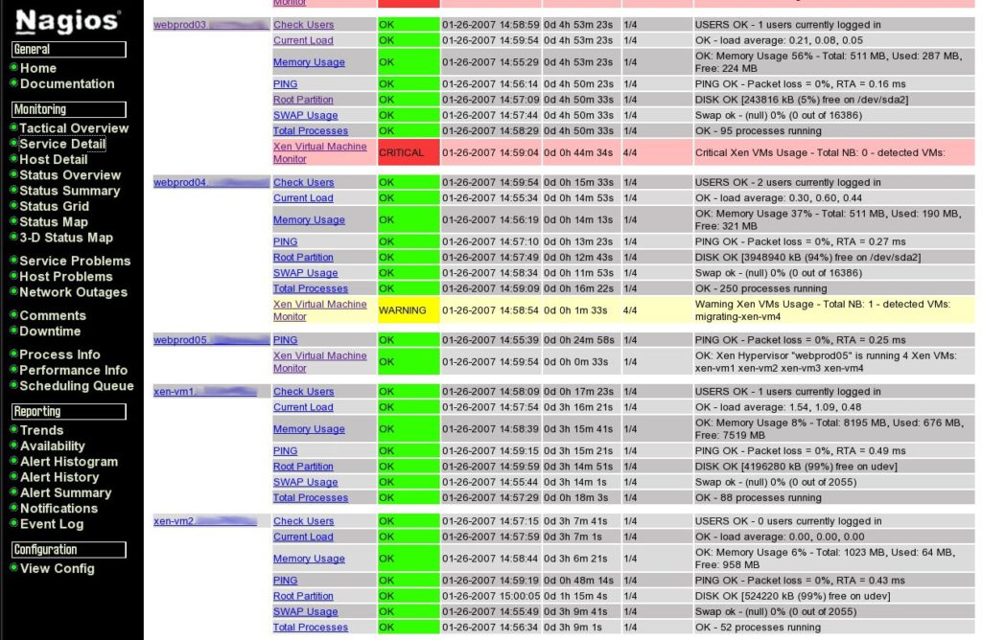

Nagios is a database monitoring tool also offering MySQL monitoring, Postgres monitoring, Oracle monitoring, DB2 monitoring, and Microsoft SQL Server monitoring.

**6.16.1. NAGIOS VERSIONS:**

It comes in two versions: Nagios Core is open source, popular, and is driven by a large community of support, while Nagios XI is the paid version.

**6.16.2. FEATURES**

[Database monitoring](https://www.solarwinds.com/database-performance-analyzer/use-cases/sql-database-monitor) with Nagios covers everything from database and table sizes to availability and cache ratios. It’s great for rapid detection of database failures, outages, and table corruption.

As an open source tool, Nagios Core isn’t as user-friendly as many paid solutions. And both versions rely heavily on add-ons and plugins for a full range of features. The advantage to this is you can choose your own add-ons and plugins, essentially building your own tool and making it work on your terms. The key disadvantage is maintaining the system becomes trickier when there are lots of add-ons and plugins involved. Keeping it up to date gets cumbersome and the system itself can become less streamlined.

**6.16.3. AVAILABILITY**

You can download Nagios Core for free.

**6.17.**[**OPSVIEW**](https://www.opsview.com/solutions/database-monitoring-tools)

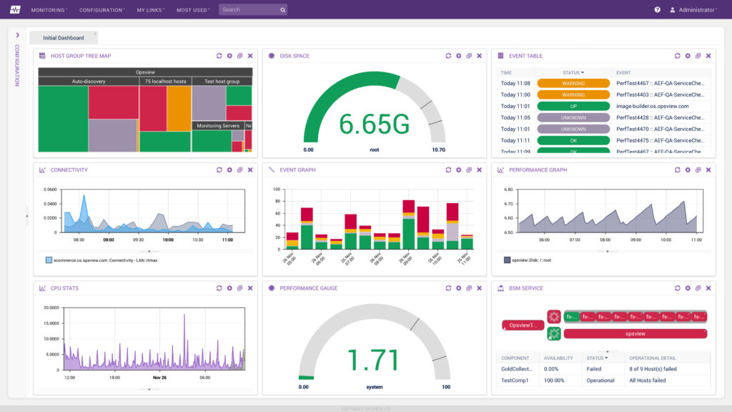

**Fig.17.Opsview monitoring**

Opsview specializes in cloud monitoring tools and offers a range of database monitoring solutions both powerful and insightful. Although Opsview is a provider focusing on cloud solutions, its database monitoring tools can be used both on-premises and in the cloud. The tools are suitable for Oracle, MySQL, InfluxDB, SQL Server, and PostgreSQL monitoring.

**6.17.1. FEATURES**

Opsview features configuration bundles called Opspacks. The Opspacks for database monitoring include monitoring for AWS DynamoDB, DB2, Exchange, MariaDB, LDAP, and many others. These Opspacks are distinct, each with its own related service checks and approach to monitoring.It also offers monitoring capabilities for applications, cloud-based services, networks, servers, and Windows.

1. **CONCLUSION**

All of the products listed above are valuable database monitoring tools in their own right. However, if we are limited to two, [**SolarWinds Database Performance Analyzer for SQL Server**](https://www.comparitech.com/go/solarwinds-database-performance-analyzer-sql-free-trial/l/conclusion_dd_d__post__106499/d/106499/d/106499/), **[ManagEngine Applications Manager](https://www.comparitech.com/go/manageengine-applications-manager-learn-more-best-database-monitoring-tools/l/conclusion_dd_d__post__106499/" \t "_blank)**, and **[Paessler PRTG Network Monitor](https://www.comparitech.com/go/paessler-prtg-database-monitor-free-trial-4/" \t "_blank) is recommended**. SolarWinds Database Performance Analyzer for SQL Server should be the top pick for any organization serious about overseeing database performance long term. However, if we like to combine a network monitoring experience alongside our SQL monitoring activities then **[Paessler PRTG Network Monitor](https://www.comparitech.com/go/paessler-prtg-database-monitor-free-trial-4/" \t "_blank)** is the better choice. It has the ability to monitor a variety of SQL databases and delivers a scalable pricing structure that is suitable for organizations of all sizes.